Selenium Basics

- Types of exceptions faced in Selenium WebDriver
- NoSuchElementException
- NoSuchWindowException
- NoSuchFrameException
- NoAlertPresentException
- ElementNotVisibleException
- ElementNotSelectableException
- TimeoutException
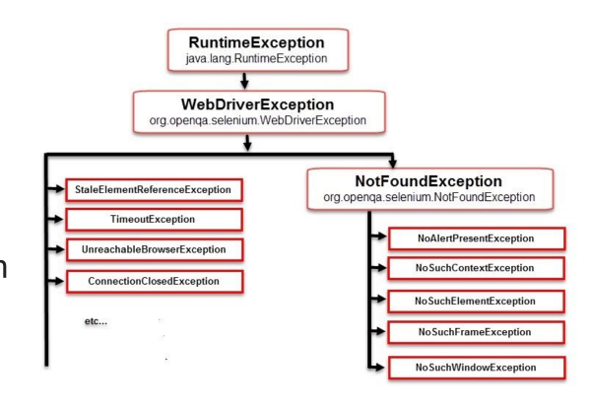

- Implicit wait in Selenium WebDriver
The implicit wait will tell the WebDriver to wait a certain amount of time before it
throws a “No Such Element Exception.” The default setting of implicit wait is zero. Once you set the time, the web driver will wait for that particular amount of time before throwing an exception.
Syntax: driver.manage().timeouts().implicitlyWait(30, TimeUnit.SECONDS);
- WebDriver Wait in Selenium WebDriver
Explicit waits are a concept from the dynamic wait, which waits dynamically for
specific conditions. It can be implemented by the WebDriverWait class

Syntax:
//To be uploaded

- Syntax to Send Keyboard keys like press Enter key on text box in Selenium WebDriver
driver.findElement(By.Id(“button_id”)).sendKeys(keys.ENTER);

- Difference between driver.get(“URL”) and driver.navigate().to(“URL”) command

driver.get() is used to navigate particular URL(website) and wait till page load.
driver.navigate() is used to navigate to particular URL and does not wait topage load.
- Pause a test execution for 5 seconds at a specific point using wait command. driver.wait(5);
- Open source frameworks supported by Selenium WebDriver
- TestNG
- JUnit
- Cucumber
- Robot Framework
- Appium
- Protractor

- Types of navigation commands in Selenium-
- navigate().to();
- navigate().forward();
- navigate().back();
- navigate().refresh();
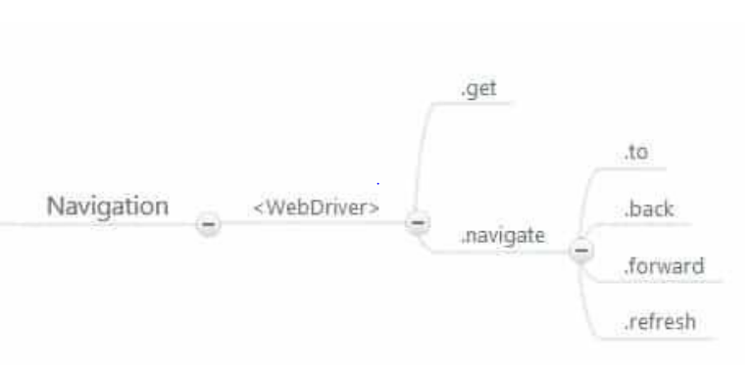

- Syntax
maximize browser window in Selenium WebDriver: driver.manage().window().maximize();
Delete all the cookies: driver.manage().deleteAllCookies();

